Project Progress Report for <sgEventHub>

Practice Module for Certificate in Designing Modern Software Systems

Team <03>

Members:

Liu Yikai

Li Jiayu

Zhang Kaidi

Fang Ziyue

Kyaw Lin

CONTENTS

1. Introduction 3

1.1 Project Name & Description 3

1.2 Project Methodology 3

1.3 Project Summary 3

2. Project Progress Report 4

2.1 Reporting Period 4

2.2 Sprint Number 4

2.3 Sprint Objectives 4

2.4 Sprint Accomplishment 4

2.5. Sprint Burn Down Chart 4

2.6. Problems Encountered, Action plan, Status 5

2.7 Sprint Retrospective 6

# Introduction

## Project Name & Description

Project name is sgEventHub which organize event and managing the participants require helping hands for Community Centre in Singapore. Especially when number of participants are huge, and event require customise options it is not easy task to host the successful event. If community hire event organizer for the events, cost of getting third party is extra wastage for community. Volunteers demand centralize organizer system to manage events.

## Project Methodology

In this project, we will be using scrum methodology to facilitate project activities such as

* Sprint Planning.
* Daily Scrum.
* Sprint Review.
* Sprint Retrospective.
* Sprint Backlog Refinement.

## Project Summary

This is java-based web application which will serve community members a feature rich, user friendly platform. Project is designed to build with java backend and node.js framework as front-End. Since there are five members in the project development two developers are taking care of backend API generation. One developer for test cases, one for node.js interfaces, and the other for ci/cd pipeline, project coordination. All the project members are responsible for documenting their works along the project implementation.

# Project Progress Report

## Reporting period: from 6-Feb-2024 to 15-Feb-2024

## 

## Sprint Number:

Spring 1

## Sprint Objectives:

### infrastructure setup (done)

### user login/reg development (partially done)

### discussion on overall structure. API plan/ UI wireframe (in progress)

2.4. Sprint Accomplishment (Summary of work plan vs actual)

## Planned: 31, Accomplished: 10

## Started planning a scope of sprint1 during the first meeting of members. Decided to create repository for backend and frontend project and start from baseline coding setup.

1. In second meetup demonstration of API sample using spring boot java project and node.js project sample. Both published at the GitHub repositories.
2. Held a knowledge sharing on how to use JIRA as an agile tool.

## Sprint Burn Down Chart

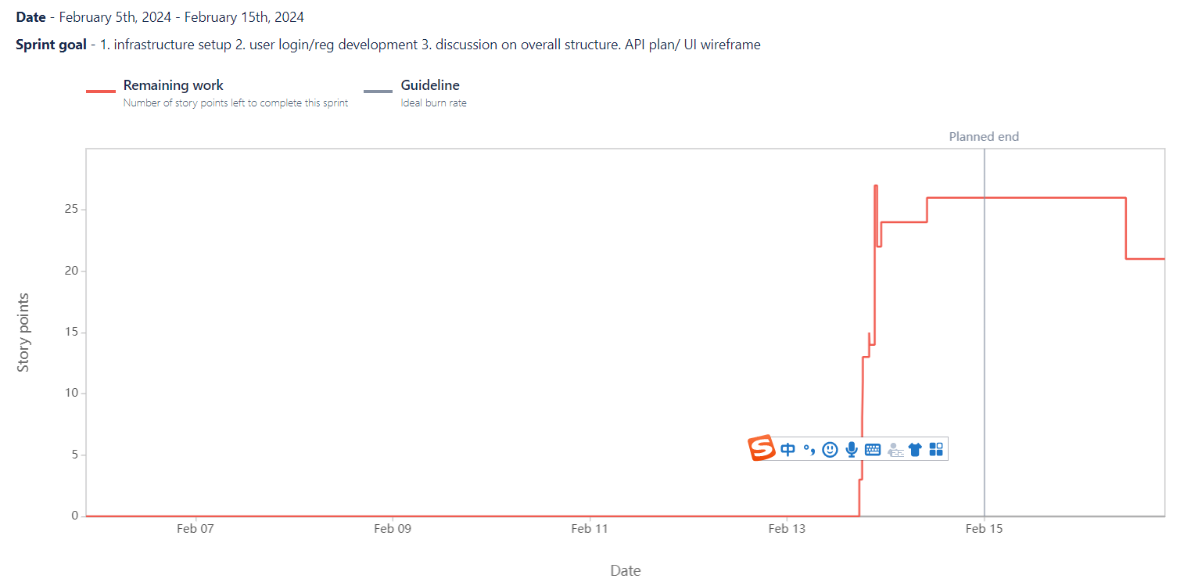

* 1. Problems Encountered, Action Plan, Status
  2. Integration of React, Redux, and Node.js with Spring Boot:
* Problem:
* The team decided to use mainstream technologies like React, Redux, and Node.js for the front-end, but integrating them with Spring Boot (backend) poses technical challenges.
* Action Plan:
* Research best practices for integrating React, Redux, and Node.js with Spring Boot.
* Collaborate with team members to share knowledge and explore solutions.
* Status:
* Ongoing efforts to bridge the gap between front-end and back-end technologies.
  1. Team Scheduling During Lunar New Year:
* Problem:
* Coordinating team members’ schedules during the holiday season has been challenging due to various commitments.
* Action Plan:
* Prioritize asynchronous communication and flexible meeting times.
* Adjust expectations regarding response times during the holiday period.
* Status:
* Continuously adapting to accommodate team members’ availability.
  1. JIRA and Excel Documentation:
* Problem:
* Recording sprint progress using JIRA and Excel has been cumbersome.
* Action Plan:
* We had a knowledge sharing session on how Jira helps with agile process by member who already have some experience with Jira.
* We make one member the Scrum master who manages the JIRA boards and Sprint timelines. In the future
* Simplify documentation by focusing on essential details.
* Status:
* Ongoing efforts to make team members more used to track their work progress with an agile setup.
  1. Sprint retrospective
     1. What went well?

1. Successful planning of Sprint 1 tasks before the Lunar New Year.
2. Team members’ expertise in Node.js and Spring Boot provided strong support.
3. Active communication and collaboration within the team.
4. The team as a whole is getting used with agile methodologies and tools such as Jira.
   * 1. What could have done better?
5. Integration Challenges: Integrating React, Redux, and Node.js with Spring Boot has been challenging. We need to explore best practices and share knowledge to address this.
6. Holiday Scheduling: Coordinating team members’ schedules during the Lunar New Year holiday remains a challenge. We should prioritize asynchronous communication and adjust response expectations.
7. Documentation Burden: Using JIRA and Excel for progress tracking has been cumbersome. We’ll explore more efficient tools or streamlined processes.
8. Teammate should be more responsible for updating their task status on JIRA.
9. Due to team’s lack of experience with JIRA, we didn’t start sprint on time until 13th Feb. The stories were not properly pointed neither. We decide to have one team member as the scrum master who manages all sprint start/end dates and regularly remind the team to update their status.
10. The burndown chart doesn’t look good. Reasons could be team’s unfamiliar with JIRA, member’s leave plan, and lack of an overall understanding of the product. To fix first 2 points, we will make sure we hold proper Sprint planning meetings. Meantime we’ll try make use of what we learnt in the SAD lectures and use UMLs to properly design the software architecture.
    * 1. What will try next?
11. Investigate better ways to integrate front-end and back-end technologies.
12. Continue adapting to team members’ availability during the holiday season.
13. Simplify documentation methods to focus on essential details.
14. Gradually design our CICD pipelines including the database servers and GitHub Actions flow.